Jtb Dive LogBook
User Manual


Table of content
Table of Contents
1 General presentation 4
2 Installation 5
2.1 Folder structure 5
2.2 Configuration 5
3 Using the application 7
3.1 The graphical interface 7
3.2 Create and open a logbook 7
3.3 Creating a diver 8
3.4 Creating a dive site 9
3.5 Preferences 9
4 Viewers 11
4.1 Browser 11
4.2 Editor 11
4.3 Diver Manager 13
4.4 Dive site Manager 14
4.5 Modified dives 14
4.6 Statistics 14
4.7 Logbook detail 14
4.8 Diver Detail 14
4.9 Dive site Detail 14
4.10 Console 14
4.11 Tasks 14
5 Import / Export 15
6 Generate a report 16
7 List of shortcuts 18
7.1 General shortcuts 18
7.2 Views shortcuts 18

Table of illustrations
Illustration 1: Folder structure 5
Illustration 2: Configuration wizard 6
Illustration 3: Home page and default layout 7
Illustration 4: New logbook dialog 8
Illustration 5: New diver dialog 9
Illustration 6: Preferences dialog 10
Illustration 7: Logbook dive browser 11
Illustration 8: Dive editor - Parameters 12
Illustration 9: Dive editor – Dive Profile 12
Illustration 10: Dive editor – Dive Equipment 13
Illustration 11: Dive editor – Dive Documents 13
Illustration 12: Modifications 14
Illustration 13: Report Options 16
Illustration 14: Generated Report 17

- General presentation
Jt’B Dive Logbook is a Java application that manages the dives that are registered in a logbook. The goals of this project are multiple. First, none of the freeware logbook application really fitted the needs of the developers. Secondly, having a project is a good challenge and stimulates the grown of knowledge in IT world. But as many Open Source projects, we’d be pleased to help people and facilitate their day-to-day dive management. Of course, anybody who would like to join the team, give som feed-back or report a bug is always welcome!
We choose the Java language for many reasons, but the mains are that Java is still a very portable solution (due to its high platform-independency) and that there is a large Java community, offering a lot of useful libraries. The choice of a swing application is because a web based solution needs the installation of a web server, which is not a good thing when using Jt’B Dive Logbook as a stand-alone version.
The approach of the software is that many logbooks can be managed at the same time with only one configuration. Therefore, some “objects” (like divers and dive sites) are managed centrally and do not need to be recreated for every logbook. This is just the philosophy of a central database where you don’t want a data to be stored twice. This approach has advantages (no double encoding, storage saving,… ) but also disadvantages (maybe you’d like to have a list of all the dive sites for example, but this makes no sense in our approach). Anyway, we choose the central storage because the benefits are (according to our meaning) higher. For the moment, the data are only persisted locally in XML files, but the design allows to be extended easily to have multiple kind of persistence layers (relational database, object database, other file formats, … ). So if somebody wants to implement one of this branch, feel free ☺ !
- Installation
  - Folder structure
There is no installation needed to run Jt’B Dive Logbook (but well a configuration). But the presence of a java virtual machine on the computer is required. The structure of the folders is as follow:
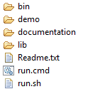Illustration 1: Folder structure
- Bin folder contains the platform specific libraries.
- Demo contains a few logbook demo’s exported in different formats.
- Documentation contains the documentation files
- Lib contains the java libraries used
- Readme.txt is a quick description file in order to start using the application
- run.cmd is the execution file to start the application on a Windows platform
- run.sh is the execution file to start the application on a Linux platform (don’t forget to make this file executable in order to use it)
  - Configuration
When running the application for the first time, you need to configure it. This configuration can be adapted once you’re using the application. A wizard prompts in order to configure the persistency parameters (the way the information is stored). Actually there is only one way to save the data: the XML format. In a future, it will maybe be possible to choose other persistency modes.

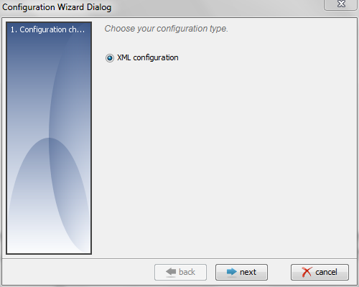 | 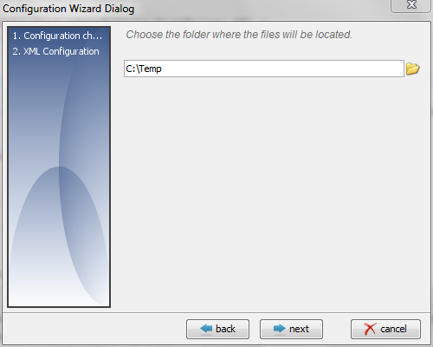
Illustration 2: Configuration wizard

- Using the application
  - The graphical interface
When the application is started for the first time, the home page is displayed. This page contains a link that will let you start the program but also a link to the web site. When clicking on “Start application”, the default layout is prompted.
The application is built with a docking framework that allows the user to choose its best layout, to move / resize the panels and display some extra “viewers”.

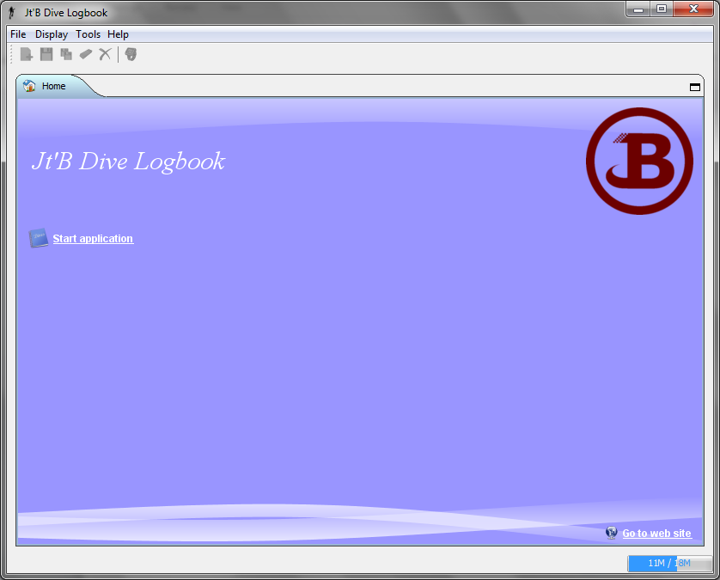 | 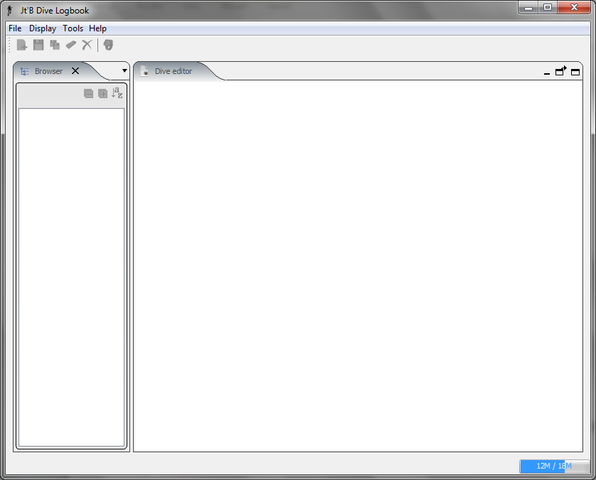
Illustration 3: Home page and default layout
  - Create and open a logbook
When creating a logbook, you need to link it to a diver. Therefore, you must be sure the diver exists. The creation of a diver is described in the section here under (see 3.3 Creating a diver).
To create a new logbook, go to the menu and select “File > New”. In the dialog, you need to enter a logbook name and an owner for the logbook. These 2 fields are mandatory and the button “Save” can only be accessed if the 2 boxes are filled.
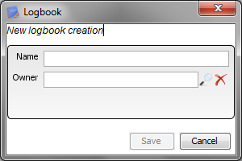Illustration 4: New logbook dialog
Once the logbook is saved, the application loads it. Of course, at this point there is no dive registered yet.
To open a logbook, click in the menu on “File > Open”. A dialog will be prompted with a list of already registered logbooks. You just have to select one to open it. If another logbook was already open in the application, the new one will replace the old one in all the viewers.
  - Creating a diver
When a diver needs to be created, modified, deleted or even merged with another one, you need to open the Diver Manager viewer (see 4.3 Diver Manager).
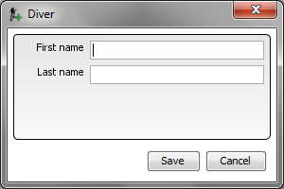Illustration 5: New diver dialog
  - Creating a dive site
When a diver needs to be created, modified, deleted or even merged with another one, you need to open the Dive site Manager viewer (see 4.4 Dive site Manager)
  - Preferences
User preferences can be accessed via the menu “File > Preferences”. As these are subject to evolution, it’s not the goal to describe them here, but as many applications; the preferences are saved locally in the profile of the current user and are loaded at the startup of the program.
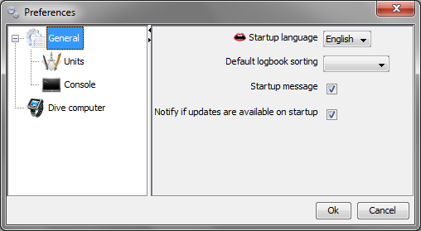Illustration 6: Preferences dialog
Normally the preferences are clear enough to know what they’re about.
- Viewers
All the viewers can be accessed via the menu “Display > Show” or by pressing one of the shortcut key (see Import / Export).
  - Browser
The browser allows you to have a tree representation of the dives contained in the logbook. The tree can be expanded or collapsed using respectively the or button. The order used to display the dives can be changed using the button. Clicking on the button will automatically open (or give the focus) the Logbook Detail viewer (see 4.7 Logbook detail). Double-clicking on a dive will open it the Editor viewer (see 4.2 Editor).
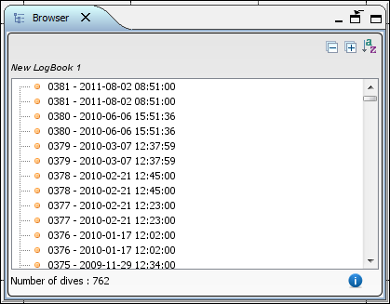Illustration 7: Logbook dive browser
  - Editor
The editor is probably the most important viewer. Once a dive is displayed in this viewer, the access to the save button (also save all) in the menu bar is possible. There a 4 tabs that describe a dive, each one with its own functionality.
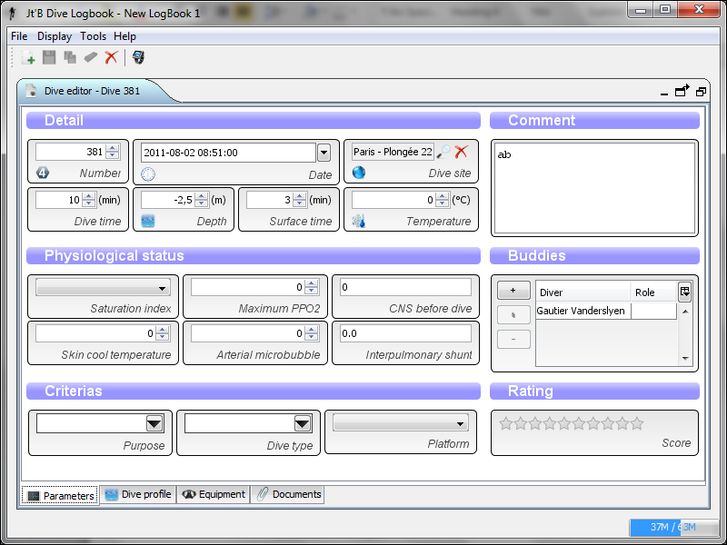Illustration : Dive editor - Parameters
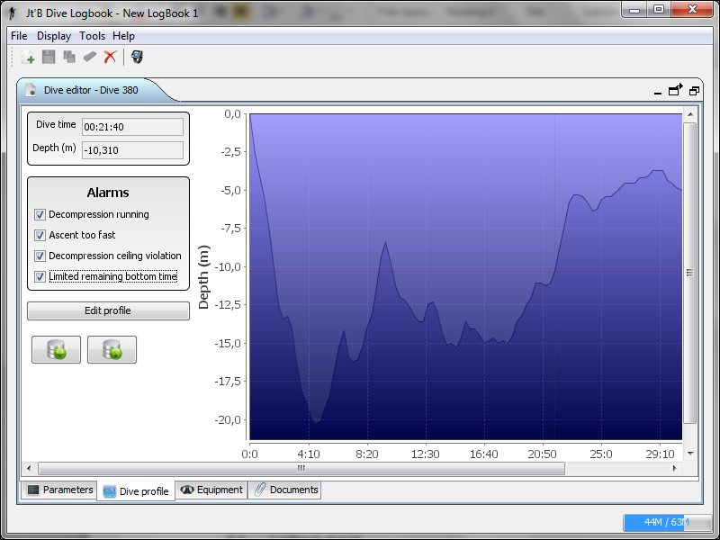Illustration : Dive editor – Dive Profile

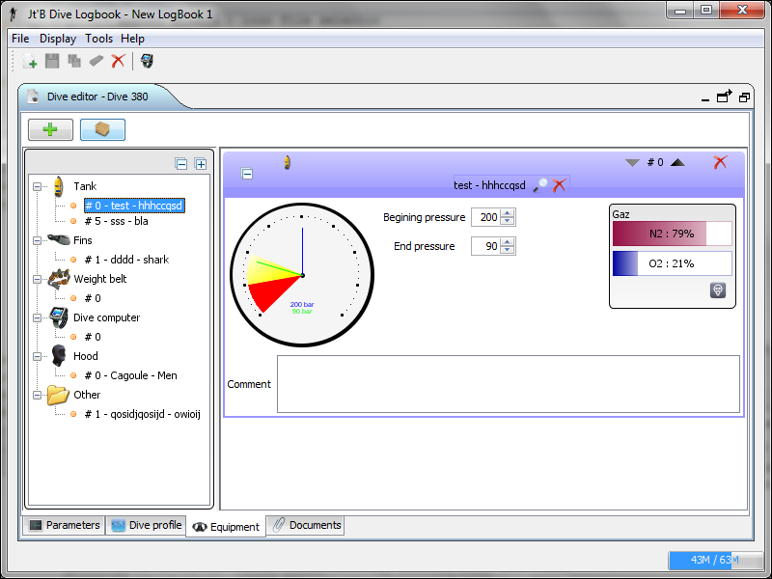Illustration : Dive editor – Dive Equipment

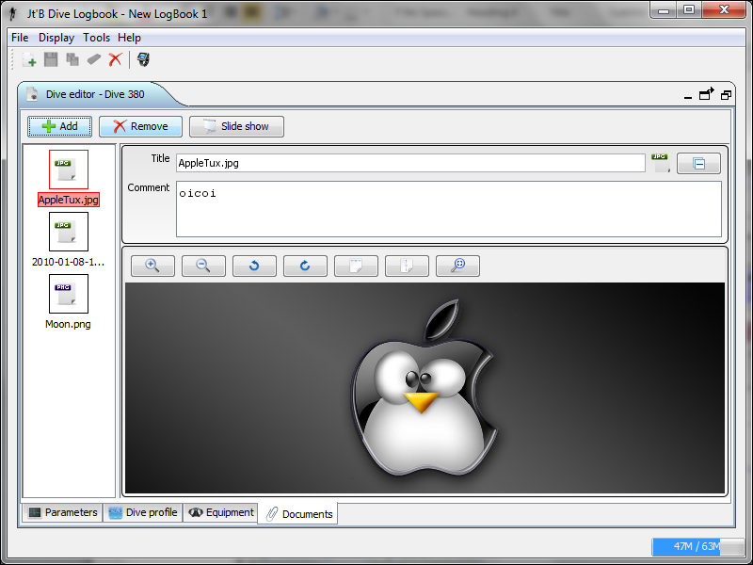Illustration : Dive editor – Dive Documents
  - Diver Manager
  - Dive site Manager
  - Modified dives
This view gives the list of all the dives that have been modified but not saved yet. You can proceed to a save in bulk by using the button.
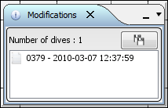Illustration 12: Modifications
  - Statistics
This viewer can be used to perform some statistical queries through the logbook. The result of the query is displayed as a graph.
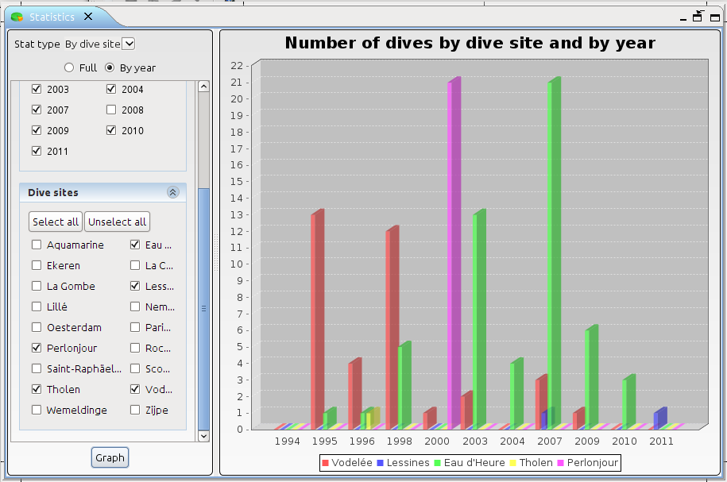Illustration 13: Statistics
  - Logbook detail
This view gives the main caracteristics of the logbook. Thoses are updated everytime a change occurs.
  - Diver Detail
This viewer is used to display the detail of a diver using only one panel.
  - Dive site Detail
This viewer is used to display the detail of a dive site using only one panel.
  - Console
The console traces the logs of the application. The log level can easily be changed there, but it only changes the current level and don't change the startup log level, which can be modified in the preferences dialog ( see 3.5 Preferences).
Some other features can be found here such as the number of lines to display, a “copy-to-clipboard” functionality of a button to select the order in which the log entries may appear.
  - Tasks
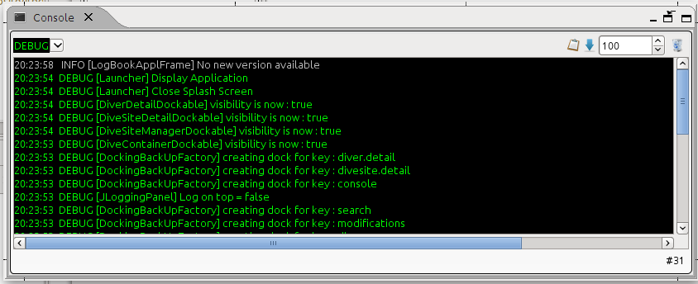Illustration 14: Logging console
  - Search
This viewer can be used to perform some search actions. Different criterias can be used and combined to get the desired list of dives. Double-clicking on a dive in the list will open it in the Editor viewer.
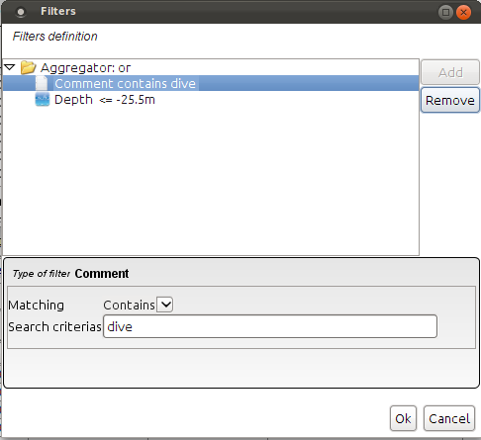

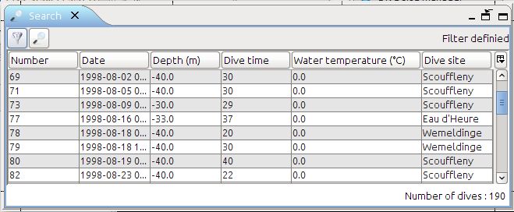
- Import / Export
The import / export functionalities can be used to deal with other software that support the same type of formats. The supported formats are:
- JtB format: the “proprietary” format which fits the best the data handled using Jt'B Dive logbook.
- JtB binaries (only import): custom format that stores raw binary data from dive computer sequences.
- UDDF : a very rich open source standard file format. Currently supported version: 3.0 and 3.1.
- UDCF : the ancestor of UDDF

- Generate a report
In order to generate a report, a logbook must be open.. In the men you can then access the “Print Report” option. A set of options is used to parameterize the report as the dives you want to see in the report.
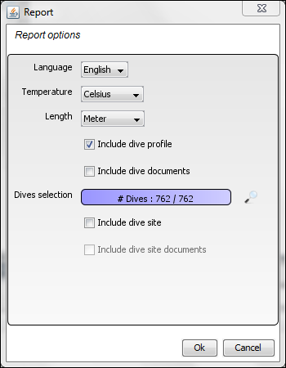Illustration : Report Options
The report generated prompts in another frame. To save (many formats are available, including pdf) or print the report, click on the corresponding button.
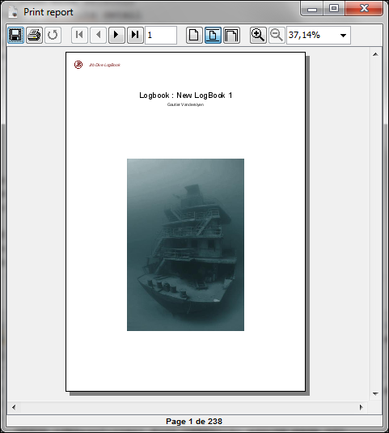Illustration : Generated Report
- List of shortcuts
The shortcuts used to perform some actions can be subdivided in 2 categories.
  - General shortcuts
Shortcut Key | Action
Ctrl + O | Open a logbook
Ctrl + N | Create a new logbook
Ctrl + C | Close the current logbook
Ctrl + E | Edit the Metadata of the current logbook
Ctrl + D | Delete current logbook
Ctrl + P | Open Preferences
Ctrl + R | Generate the report
Ctrl + Alt + E | Export Logbook
Ctrl + Alt + I | Import Logbook
  - Views shortcuts
Shortcut Key | Action
Ctrl + Shift + B | Open View ‘Browser’
Ctrl + Shift + E | Open View ‘Editor
Ctrl + Shift + D | Open View ‘Diver Manager’
Ctrl + Shift + L | Open View ‘Divesite Manager’
Ctrl + Shift + M | Open View ‘Modified Dives’
Ctrl + Shift + C | Open View ‘Console’
Ctrl + Shift + T | Open View ‘Tasks’
Ctrl + Shift + K | Open View ‘Diver Detail’
Ctrl + Shift + F | Open View ‘Divesite Detail’
Ctrl + Shift + A | Open View ‘Statistics’
Ctrl + Shift + M | Open View ‘Mat Cave’
Ctrl + Shift + I | Open View ‘Logbook Informations’
Ctrl + Shift + S | Open View ‘Search’

